Written By: | Heidi Hellman

Table of Contents
1.0 Introduction 1
1.1 Purpose 1
1.2 Scope 1
1.3 Definitions, Acronyms and Abbreviations 1
1.4 References 3
2.0 Software Description 3
3.0 Algorithm Description 8
3.1 Data Smoothing 8
3.2 Beat Detection 8
3.3 Beat Evaluation 13
3.4 Heart Rate 18
3.5 Beat Check 18
3.6 Cardiac Output 19

Introduction

Purpose
Heart Rate and Cardiac Output are derived parameters that are determined in software through analysis of the pulmonary artery pressure waveform. This software specification document presents the methods used to determine these parameters.

Scope
The scope of this document includes calculations necessary to measure Heart Rate and Cardiac Output in any applicable CardioMEMS Electronics system.

Definitions, Acronyms and Abbreviations
Term | Definition
bpm | Beats per minute
C | Compliance
CO | Cardiac Output
CO₀ | baseline cardiac output as measured from a reference catheter, generally captured at the time of sensor implant
dPdt | derivative of pressure waveform
End diastole | End of relaxation phase of cardiac cycle, generally the minimum point of the pressure waveform, also called start systole
Heart beat | One cycle of a cardiac cycle, including diastole and systole phases. For algorithm purposes, a heart beat is from one End Diastolic point to the subsequent End Diastolic point.
HR | Heart Rate
max dPdt | Maximum derivative of pressure waveform
mean PAP | Mean pulmonary artery pressure, average of data points from pressure waveform for a single beat or across a 10 or 18 second waveform
mPAP | Mean PAP
mSPAP | Mean systolic pulmonary artery pressure – mean of Pd and Ps
mSPAP₀ | baseline mean systolic PAP. Used for Cardiac Output calculation. Measured from the pressure waveform captured when the baseline CO is stored.
PA | Pulmonary artery
PAP | Pulmonary artery pressure
Pd | End Diastolic Pressure
Ps | Peak Systolic Pressure
Pi | Incident RV Pressure
SV | Stroke Volume
Td | Time of end diastole
Ti | Time of incident pressure wave
Tn | Time of dicrotic notch
Ts | Time of systolic peak
Table 1: List of terms defined for use in the following report.

References

Applicable Documents
None

Reference Documents
Number | Title
SO-500111 | I2 Patient Application Software Requirements Specification
SO-500455 | I2 Hospital Application Software Requirements Specification
SO-500478 | I3 Patient Application Software Requirements Specification
TR-1002-263 | Clinical Validation of Cardiac Output Derived from the CardioMEMS Sensor PAP Waveform
Table 2: List of documents to be referenced throughout this report.

Software Description
Heart rate and cardiac output are pre-existing system parameters that are derived from analysis of the pulmonary artery pressure waveform. This design document describes the methods used to derive these parameters, which are implemented in the device software.

During sensor readings, each beat of the pulmonary artery pressure (PAP) waveform is analyzed to identify the following features:

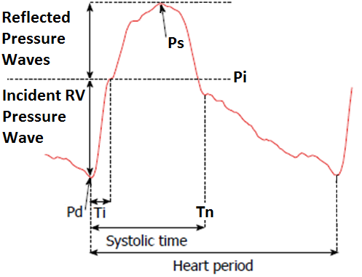
High Fidelity PA Pressure Waveform with Features Identified

Heart rate is determined as HR (beats per minute) = 60(s/min) / Heart period (s/beat).

Cardiac Output is determined using parameters determined through analysis of the pressure waveform. There are two versions of the Cardiac Output algorithm – termed “current” and “future” in this document. The future version of the cardiac output algorithm, as presented in this description, differs from the first version in the following ways:

- The pressure on the systolic upslope at the incident point prior to peak systole is used as the scaling factor for stroke volume
- Compliance related changes in the pressure to volume relationship after baseline calibration are incorporated.
Note that Systolic Time, as identified in the figure above, is not used in the CardioMEMS system. T_{s} is used instead, which is the time of the systolic peak.

Algorithm Description
The following steps are followed to determine heart rate and cardiac output from the pulmonary artery pressure waveform.
- Data Smoothing
- Calculate Derivatives
- Beat Detection
- Beat Evaluation
- Beat Check
- Pressure and HR Calculation
- Cardiac Output Calculation

Data Smoothing
Data is received by the system at 250 Hz. Prior to the cardiac output algorithm the data has been expressed as a floating point number with the units of mmHg. Furthermore, it has already been filtered with a 5 pole low-pass Chebyshev filter with a cutoff frequency of 40 Hz.
Additional smoothing is performed on the data to reduce potential waveform artifact influence on feature selection.
- For initial beat detection, the smoothing is a boxcar average of 10 points such that the smoothed output is the average of the 10 points around the current point.
- For the incident wave detection the smoothing is a boxcar average with a length of 6 points.

Beat Detection
Beat Detection is the first pass analysis of the pressure waveform that identifies the initial points of End Diastole and Systolic Peak. Beats are identified by looking for relative minima and maxima in the pressure waveform. The search proceeds looking for minima and maxima in alternating states.

Initial Systolic Peak
The Systolic Peak is defined as the maximum pressure after the systolic upslope.
In the state looking for a maximum, the initial Systolic Peak, the starting guess for the maxima is set to a low value and then each point that exceeds becomes the new maxima. Initial Systolic Peak is captured as the maximum value that has been found when the pressure becomes lower than the running value of the noise threshold, which is described below.

Initial End Diastole / Start Systole
The end of diastole or start of PA systole is noted in the pulmonary pressure waveform as the corner where the pressure signal starts to rise rapidly, indicating pulmonic valve opening.
The software then alternates to look for the minimum, the initial End Diastole, of a beat. The criteria are used in a similar way. The starting guess for the minimum is set to a high value and then each point that is less than the current minimum becomes the new minimum. Initial End Diastole is captured as the minimum value that has been found when the pressure becomes higher than the running value of the noise threshold.

Noise Threshold
Noise threshold is a dynamic, running value that determines when the Beat Detection algorithm switches between looking for maxima and systole versus minima and diastole. Noise Margin, which is used to determine Noise Threshold, has a minimum of 2 mmHg and a maximum of 50 mmHg. The method allows the system to be able to detect real heart beats as small as 2 mmHg but prevents detecting the dicrotic notch as a minimum. The 50 mmHg maximum eliminates the potential of noise artifact that exceeds the normal physiological range for a pressure pulse from affecting the noise threshold.
Generally, Noise Threshold = pressure ± noise margin
The Noise Threshold is calculated differently depending on what phase the algorithm is in: looking for maximum (systole) or looking for minimum (diastole).
- Looking for minimum or end diastole
  - Phase begins when current pressure drops below current noise threshold. That is, the noise threshold for the detection of the next end diastole and next beat is set when the Systolic Peak is identified for the current beat, which occurs after the pressure decreases below the current running noise threshold.
  - Noise Threshold = current minimum + Noise Margin
  - Current minimum is generally decreasing in this phase. That is, until the pressure waveform bottoms out, the current minimum is usually equal to the current pressure.
  - Noise Margin starts at (initial systole pressure – initial diastole pressure) and decays exponentially with a time constant of 0.3 seconds to a minimum of 2 mmHg
- Looking for maximum or peak systole
  - Phase begins when current pressure exceeds current noise threshold
  - Noise Threshold = current maximum – Noise Margin
  - Current maximum is generally increasing in this phase. But after a peak is reached, the noise threshold will flatten out, because the current maximum remains the same.
  - Noise Margin is the last value of noise threshold before switching to this phase?

To illustrate, consider the pressure waveform and corresponding analysis shown below.
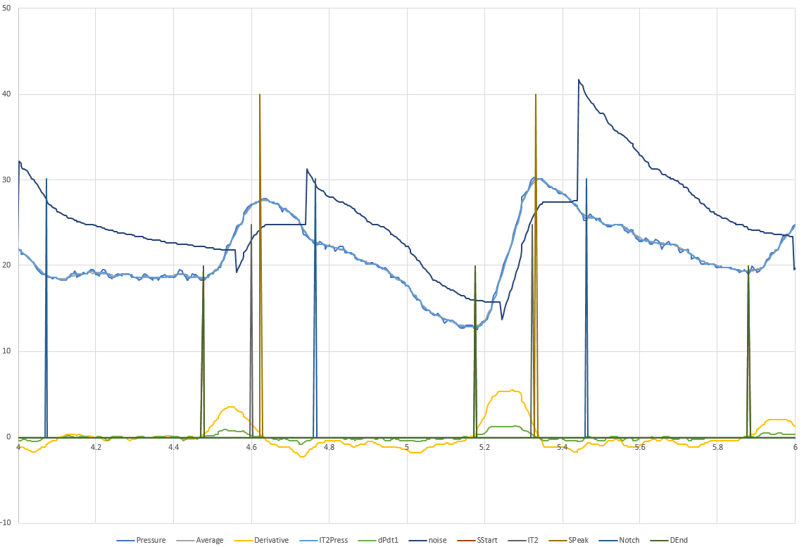


Looking for peak systole
A

End Diastole
Peak Systole
PS
ED
Noise Threshold – darker blue

Pressure Waveform – lighter blue

A

PS
PS
D

ED
ED
Looking for end diastole
E

C

B

- See 1.a. above. When pressure drops below current Noise Threshold, the algorithm (1) confirms that a maximum (initial systole) has been found and (2) switches to looking for minimum (end diastole), which includes resetting the Noise Threshold.
Noise Threshold is reset, which is the instantaneous increase after point A.
Noise Threshold is reset to current pressure + Noise Margin, where
Noise Margin = current pressure max – current pressure min
= initial peak systolic pressure – initial end diastolic pressure.
Noise Threshold = current pressure + (initial peak sys. pressure – initial end dias. pressure)
- See 1.b, 1.c, and 1.d above. Noise Margin exponentially decays. Noise Threshold = current minimum + Noise Margin. During diastole, current minimum is usually the current pressure.
- See 2.a above. Pressure increases above noise threshold. The algorithm confirms that a minimum (initial end diastole) has been found and switches to looking for maximum (peak systole) which resets the Noise Threshold. The Noise Threshold reset is the instantaneous drop in threshold just after point C.
Noise Threshold is reset to (current pressure - Noise Margin), where Noise Margin is unchanged. It keeps decaying from the previous phase.
- See 2.b, 2.c, and 2.d above. Noise Threshold = current pressure maximum – Noise Margin. Noise Margin is low and current maximum is increasing. Because each point on the pressure waveform is usually increasing during systole, the current maximum is usually the current pressure.
- See 2.c above. Noise threshold is flat because current maximum isn’t changing after the pressure peak.

Lockout
Downslope, when looking for minimum and End Diastole
To further avoid detecting the dicrotic notch as initial End Diastole there is a lockout parameter, set to 0.2 seconds. Initial Systolic Peak and the subsequent initial End Diastolic point must not be within 0.2 seconds. Minima found within 0.2 seconds of the previous Systolic Peak should be ignored.
Upslope, when looking for maximum and Systolic Peak
Initial End Diastole and the subsequent initial Systolic Peak point must not be within 0.04 seconds (10 samples at 250 Hz). Maxima found within 0.04 seconds of the previous End Diastole point should be ignored.

Beat Evaluation
Beat Evaluation is the second pass analysis that uses the derivative of the pressure waveform and identifies the final End Diastole and Systolic Peak points.

Calculate Derivatives
Two types of derivatives are calculated, depending on the analysis to be conducted.
- For End Diastole and Systolic Peak (Pd and Ps), as well as Time of Dicrotic Notch, Tn
  - Smooth pressure waveform with 10-point boxcar average. Complete the averaging retrospectively, so that at a given point in time, the 10-point boxcar average uses the previous 5 points and the “future” 5 points.
  - Derivative is change in pressure between two points that are 10 samples apart (10 samples is 40 ms with 250 Hz sampling)
- For Upslope RV Incident pressure point (Pi)
  - Smooth pressure waveform with 6-point boxcar average. Complete the averaging retrospectively, so that at a given point in time, the 6-point boxcar average uses the previous 3 points and the “future” 3 points.
  - Derivative is change in pressure between two points that are 2 samples apart (2 samples is 8 ms with 250 Hz sampling)
To help visualize, an example pressure waveform from two cardiac cycles, with three types of derivatives is shown.

End Diastole / Start of Systole (Pd)
- Identify the maximum first derivative (max dPdt) between an initial End Diastolic point and the subsequent initial Systolic Peak point. Max dPdt is used as a reliable reference point from which the other parameters are determined.
- Search in the reverse time direction from max dPdt.
- Final End Diastole or start of systole (P_{d}) is defined as the pressure value corresponding to when the first derivative value first drops below 10 percent of the max dPdt value.
Ten percent is near 0, and first derivatives cross 0 where their original functions or data have a local minimum or maximum.
- Note the time point of P_{d} as T_{d}
initial end diastole
max dPdt
10% of max dPdt
Pd
initial systolic peak
Note that if there are any glitches or notches in the pressure systole waveform, the true, unsmoothed first derivative of this pressure waveform would have crossed or neared 0 and caused incorrect detection of end diastole. See incorrect end diastole detection points in the example waveform below. The first derivative smoothing that occurs by using a 10-point derivative helps ensure that the notch is not detected as end diastole.

Systolic Peak (Ps)
- Use max dPdt as calculated above.
- Search in the forward time direction
- Final Systolic Peak P_{s} is determined as the pressure value corresponding to when dPdt first crosses zero
- Note the time point of P_{s} as T_{s}.

initial systolic peak
Searching forward from max dPdt, derivative crosses 0
Ts
Ps
max dPdt
initial end diastole
max dPdt

Mean Pressure during Systole (mSPAP)
The mean pressure during systole is used to determine proportional changes in vascular compliance from the baseline calibration of cardiac output.
mSPAP is calculated for each beat as the average of P_{s} and P_{d}.

Mean Pressure (mPAP)
Mean pressure for a given heart cycle, is the average of all pressure points bounded by end diastole to the subsequent end diastole.

Upslope RV Incident Pressure (Pi)
The Upslope RV Incident Pressure (P_{i}) represents the near peak of the primary RV pressure wave associated with systole. P_{i} is used instead of systolic pressure (P_{s}) in the Cardiac Output calculation to ignore the effect of secondary reflections, which can amplify the pressure waveform but are not relevant to the primary systolic contraction.

Current Pi Algorithm
- With first derivative waveform and third derivative waveform, calculated with points that are 2 samples apart, which is different than derivatives used for End Diastole and Systolic Peak
- Calculate max dPdt between P_{s} and previous P_{d}
- Starting at the next sample point past max dPdt, and searching in the forward time direction, locate the point where the 3rd derivative crosses from negative to positive and then find the next point where the 3rd derivative goes from positive to negative.
- If there was no difficulty in finding the 3rd derivative zero crossings then locate the maximum 3rd derivative point between the two zero crossings. This is Pi. This represents the location where the first derivative slope slows its decrease and reaches relative minima.
- If there was difficulty in finding the 3rd derivative zero crossings, P_{i} is the pressure value corresponding to the time point when dPdt first goes below 50% of max dPdt while searching in the forward time direction starting at max dPdt.

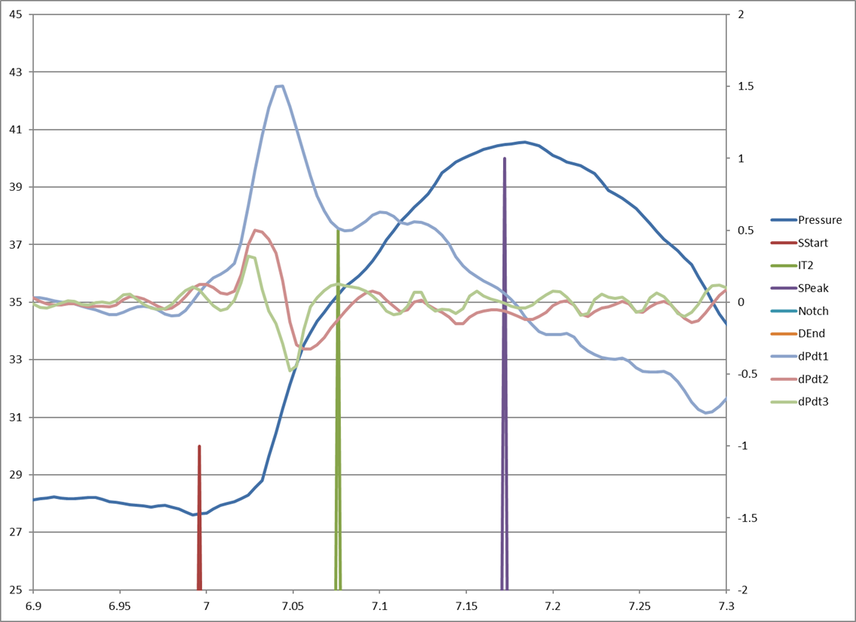
Ti
Pi
Maximum 3rd derivative between Zero Crossings
3rd derivative Zero Crossings after max dPdt
Max dPdt

Future Pi Algorithm
- With first derivative waveform, calculated with points that are 2 samples apart, which is different than derivatives used for End Diastole and Systolic Peak
- Calculate max dPdt between P_{s} and previous P_{d}
- Starting at T_{s}
- Search in the reverse time direction
- P_{i} is the pressure value corresponding to the time point when dPdt first exceeds 25% of max dPdt

max dPdt
25% of max dPdt
Ti
Pi
Ps at Ts
Pd

Tn – Dicrotic Notch Time
The Dicrotic Notch Time Tn is the point on the pressure waveform where the pulmonary valve closes. This is the end of systole. In systole, the pulmonary artery pressure waveform is actively being controlled by the heart muscle. The Dicrotic Notch Time Tn is also the beginning of diastole. In diastole, the pulmonary artery pressure waveform is controlled by the passive flow of blood into the lung capillaries. In practice, the notch has different shapes. Sometimes it has a small positive inflection and sometimes it is just a change in slope. Finding these shapes in the presence of noise requires the algorithm to have several different steps to properly isolate Tn.

- Predict an estimated notch time using heart rate as a percentage of the beat length. Heart rate is limited to the region 20 to 240 BPM. The predicted time of the notch is given by the following equation:
PredictedTn = Heart Rate * (-0.0019) + 0.465
This equation was computed empirically using the clinical patient data.
- Define a region in which to search for notch using the systolic peak to start and a percentage of the beat past the predicted notch as the end. The notch region is the following:
Notch Region = [ From Systolic Peak to PredictedTn + 30% of Beat Length ]
- The algorithm finds all threshold crossings where the derivative (10-point derivative) goes above a certain percentage of maximum negative slope. The maximum negative derivative in this context is the largest negative derivative value from the systolic peak to the end of diastole. The algorithm then locates all notch candidates in the Notch Region at the point where the derivative goes from less than or equal to 50% of the maximum negative derivative to greater than 50% of the maximum negative slope. That is:
  - Calculate first derivative
  - Locate maximum negative derivative after final systolic peak, Ts
  - Calculate 50% of maximum negative slope value
  - Searching in forward direction from Ts, identify all points in Notch Region where derivative transitions from < 50% negative to > 50% negative

- The algorithm also finds all points where derivative goes positive, locating notch candidates in the Notch Region at the point or points where the derivative goes from less than or equal to 0 to positive.

- From the notch candidates found in 3 and 4, the algorithm chooses the one closest in time to the predicted notch, PredictedTn, for Tn Dicrotic Notch Time.

- In the unlikely case that there are no notch candidates identified in 3 and 4 then the algorithm uses the predicted notch, PredictedTn, for Tn Dicrotic Notch Time.

Figure indicates different notch shapes and where each were identified via the line with medium height.
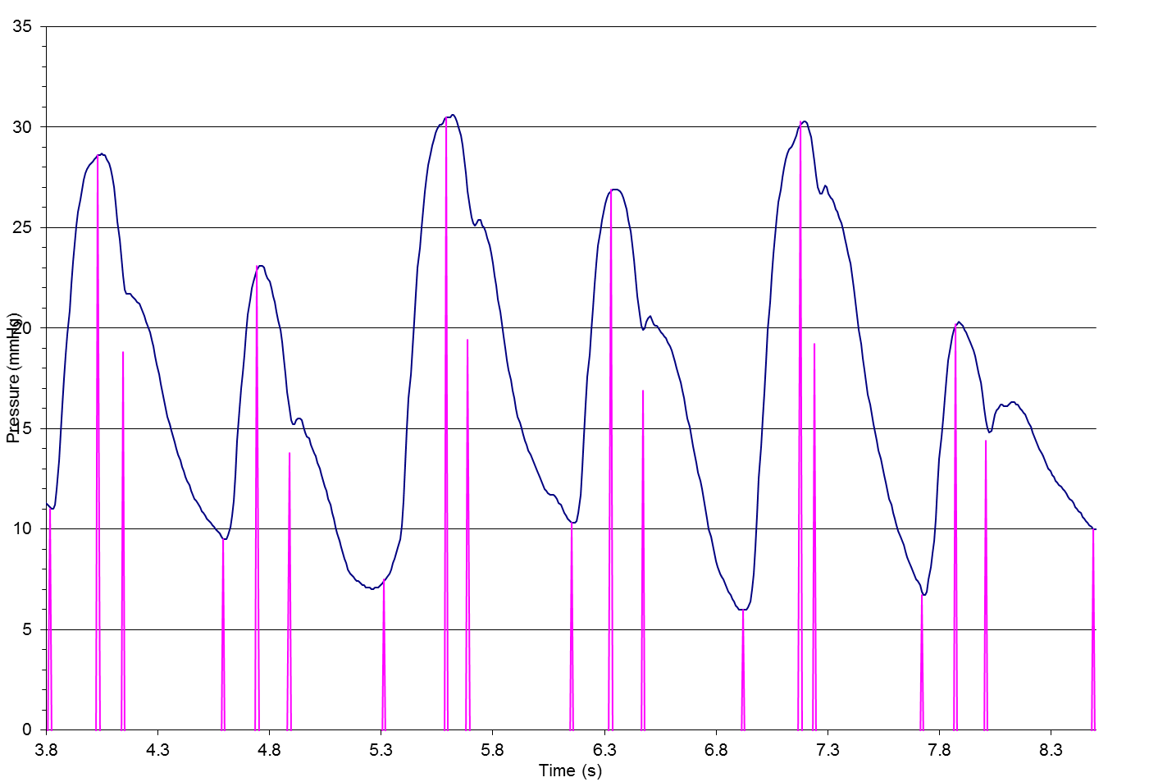

Heart Rate
Heart period is the time between two adjacent End Diastolic Pressures (P_{d}). Heart rate is calculated from heart period:
$$Heart Rate \left(bpm\right)=\frac{60 (\frac{s}{min})}{Heart Period (\frac{s}{beat})}$$

Beat Check
Following beat evaluation, the heart beats are checked to see if they have characteristics that are physiologically plausible. Designation of bad versus good beats is used to determine what beats or data are used to calculate the summary values for systolic, diastolic, and measure pressures, as well as heart rate. In addition, cardiac output will be calculated based on pressure data from only good beats.

The criteria for good beats are based on known, physiological ranges:
- Expected heart rates are within the range of 40-300 bpm.
- Systole occurs within 1/3 of the time of the heart beat.
- Start to peak systole is half of systole (1/6 of the beat).
- The pulse pressure of a PA waveform will be at least 2 mmHg and less than 100 mmHg .

Specifically, for a heart beat to be determined valid or good, all of the following must be true:
- (Peak systole time – Start systole time) must be greater than 0.033 seconds
- (Peak systole time – Start systole time) must be less than 0.5 seconds
- Pulse pressure (Peak systole pressure – End diastolic pressure) must be greater than 2 mmHg
- Pulse pressure (Peak systole pressure – End diastolic pressure) must be less than 100 mmHg
- End diastolic pressure (P_{d})) ≤ mean Pressure ≤ Peak systole pressure (P_{s})
- Signal strength is ≥ 40% for the whole beat
- Criteria 1-6 are all true for the previous heart cycle

If any of these criteria are not met then the beat is ignored and is marked as ‘Bad’.
Note that if there have been no valid beats within a reading window (10 seconds for Hospital, 18 seconds for Patient), the software classifies the rhythm as asystole, which is used to modify the displayed data.
See also the applicable I2 or I3 Application Software Requirements Specification.

Cardiac Output

Current Cardiac Output Algorithm

Cardiac output must be calibrated during sensor implant or when a simultaneous CO is measured using a reference catheter. At CO calibration:
- Calculate CO_{area} to be used in future CO calculations. COref is the CO measured by the reference catheter. HR, √Pi, and (Tn – Ti) are computed for each good beat in the 10 second PA pressure reading used for CO calibration. For the CO_{area} calculation these values are averaged to get the average HR, average √Pi and average (Tn – Ti) which are used below.

$${CO}_{area}=\frac{{ CO}_{ref}}{HR ×\sqrt{Pi}×\left(Tn-Ti\right)}$$

- Store the mPAP_{o} from the waveform captured at the time of calibration. mPAP_{o} is the mean PA pressure of the PA waveform captured over 10 seconds when the CO baseline was set in initial implant

Future CO calculations are done on a beat by beat basis, using the cycle length (HR), Pi, Tn, Ti, and mPAP for that beat, using the same calculation

$$CO =HR ×\sqrt{Pi}×\left(Tn-Ti\right)×{CO}_{area}×e^{-(0.025(mPAP-mPAPo)}$$

Note that CO is not displayed on a beat by beat basis, rather an average of calculated COs for all valid beats in the display window that is updated on a beat by beat basis.

Future Cardiac Output Algorithm

Derivation

The pressure value at the peak of the incident RV pressure wave (P_{i}), mean pressure during systole (Average of Ps and Pd = mSPAP), pulmonary artery pressure, and heart rate are variables used to determine cardiac output.

For a closed arterial system, the relationship between change in volume (ΔV) and change in pressure ΔP is defined by the vascular compliance (C):

C = ΔV / ΔP

For the pulmonary artery, ΔP is the peak change in pressure associated with the RV systole, indicated by P_{i}, ΔV is the RV stroke volume (SV), and C is the pulmonary vascular compliance. Accordingly, stroke volume is defined by:

SV = P_{i} x C

And cardiac output is defined by:

CO = HR x P_{i} x C

The compliance at baseline (C_{o}) is determined using an invasive reference CO measurement performed during the sensor implant procedure (CO_{ref}):

C_{o} = CO_{ref} / [HR x P_{i}],

Pulmonary vascular compliance is expected to vary after the baseline calibration. Changes in pulmonary vascular compliance correlate logarithmically with changes in PAP, according to the elastic strain modulus of the vessel wall, as shown in the following figure (Pasierski TJ, CHEST, 1993):
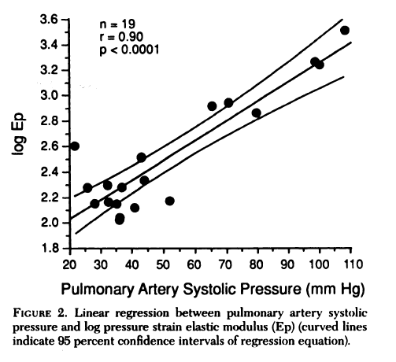
For the CardioMEMS pressure-based cardiac output method, the characteristic relationship between pressure and compliance change is determined by evaluation of the residual differences between the pressure-based CO which is determined using the initial compliance term (C_{o}) and the reference CO measurements at follow-up. The difference observed is expressed as a proportion of the calculated CO using the initial compliance:

(CO_{Sensor,Co} – CO_{Ref}) / CO_{Sensor,Co}

The multiplier term that compensates for this residual difference, which is attributed to the proportional compliance change, is expressed as:

1 - [(CO_{Sensor} – CO_{Ref}) / CO_{Sensor}]
The proportional compliance change is characterized as a function of the mean pressure during systole (mSPAP), determined by the average of Ps and Pd at the start of the beat, change from implant calibration to any later measurement (ΔmSPAP).

Based on the previously presented study showing a logarithmic relationship between compliance and pressure, the relationship between proportional compliance change and ΔmSPAP is characterized by an exponential curve

C = C_{o} e^{[A x ΔmSPAP]},

Accordingly, the pressure-based cardiac output with proportional compliance change, is calculated as follows:

CO = HR x P_{i} x C_{o} e^{[A x ΔmSPAP]}

The constant term A was determined by performing an exponential regression curve fit using clinical data. Per TR-1002-263, all available clinical follow up data was used to determine the optimized form of the model. Data collected during the Champion and Feasibility clinical studies is presented in the following chart:

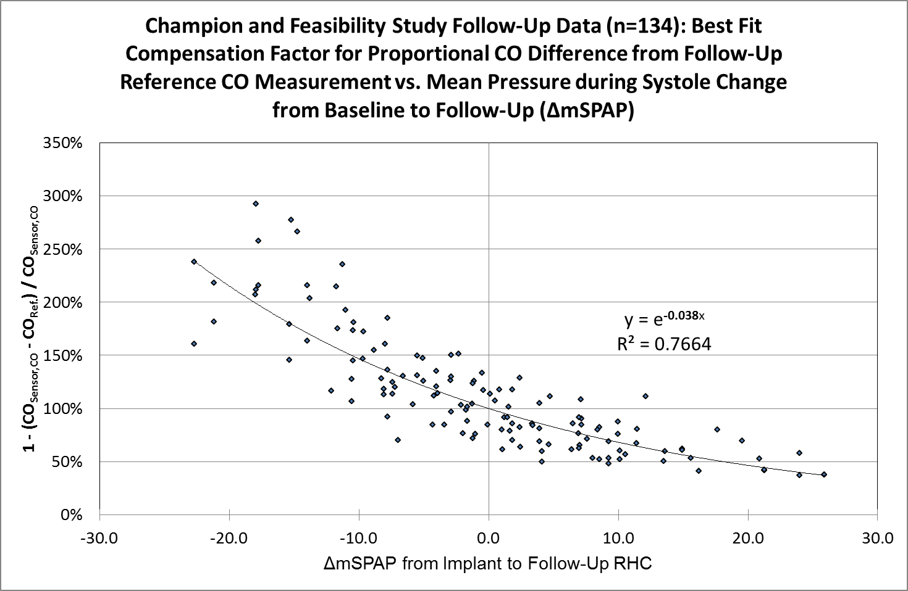

Based on regression curve-fit of the above data, the best-fit coefficient for A is
-0.038 (R² = 0.7664). Therefore the pressure-based cardiac output with proportional compliance change is calculated as follows:

CO = HR x P_{i} x C_{o} e^{[-0.038 x ΔmSPAP]}

Calculation

Cardiac output is determined on a beat to beat basis from the determined pressure waveform parameters using the following equation, as previously described above:
CO = HR x Pi x C_{o} e^{[-0.038 x (mSPAP – mSPAPo)]}
The initial value for the compliance term (C_{o}) is defined during the CO calibration step using a reference right heart catheter CO measurement (CO_{ref}), and is saved in the patient history file for use in later readings:
C_{o} = CO_{ref} / [HR x P_{i}],
The baseline mean pressure during systole (mSPAP_{o}) at the time of the CO calibration is also saved in the patient history file for use during later readings.

